Changing diel growth symmetries and light-capture in PhycoCyanin and PhycoErythrin-rich picocyanobacteria, across photic regimes and growth phases

Sylwia Śliwińska-Wilczewska1,2, Marta Konik3,4, Mireille Savoie1, Naaman Omar1, and Douglas A. Campbell1,✉

1 Department of Biology, Mount Allison University, 53 York St., Sackville NB, Canada, E4L 1C9  
2 Institute of Oceanography, University of Gdansk, 46 Pilsudskiego St, P81-378, Gdynia, Poland  
3 Department of Geography, University of Victoria, Victoria, BC V8P 5C2, Canada  
4 Institute of Oceanology, Polish Academy of Sciences, 81-712 Sopot, Poland

✉ Correspondence: [Douglas A. Campbell <[dcampbel@mta.ca](mailto:dcampbel@mta.ca)>](mailto:dcampbel@mta.ca)

# Supplementary material

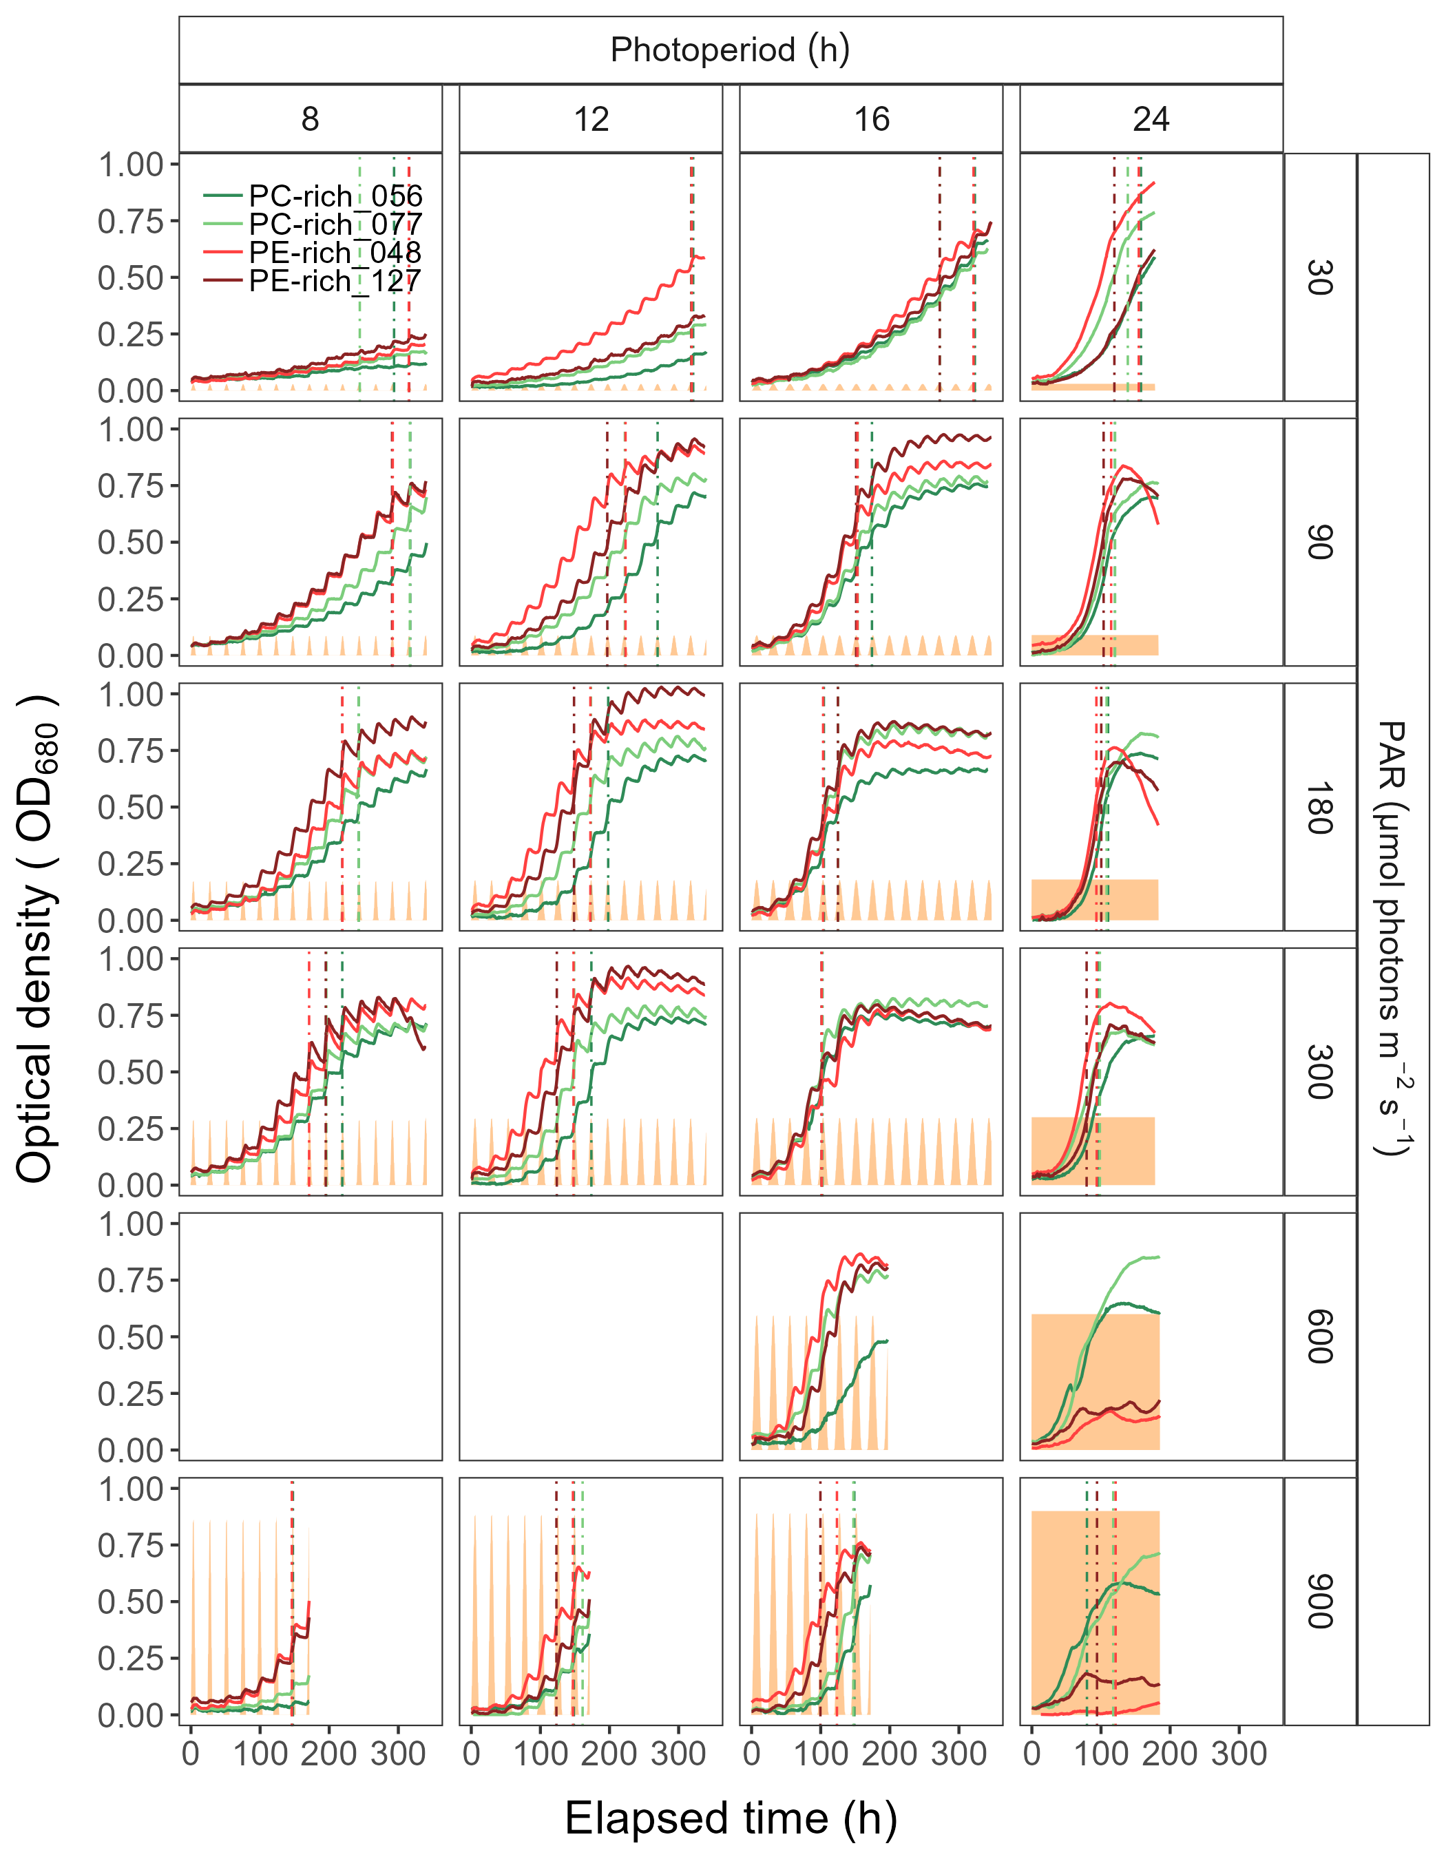

Figure 1: Example of representative growth curves (tracked as OD680) of two PhycoCyanin(PC)-rich cultures (light green line; 056, dark green line; 077) and two PhycoErythrin(PE)-rich cultures (light red line; 048, dark red line; 127) (Culture Collection of Baltic Algae) of *Synechococcus* sp. grown at 30, 90, 180, 300, or 900 peak PAR µmol photons m−2s−1; and photoperiods of 8, 12, 16, or 24 h. The vertical lines represent the time when the cultures reached their maximum absolute hourly growth (tMaxAG), taken as an index of transition from exponential to pre-stationary growth phases. The orange area represents the photoperiods, with peak PAR x 1/1000 to scale to the Y axis.

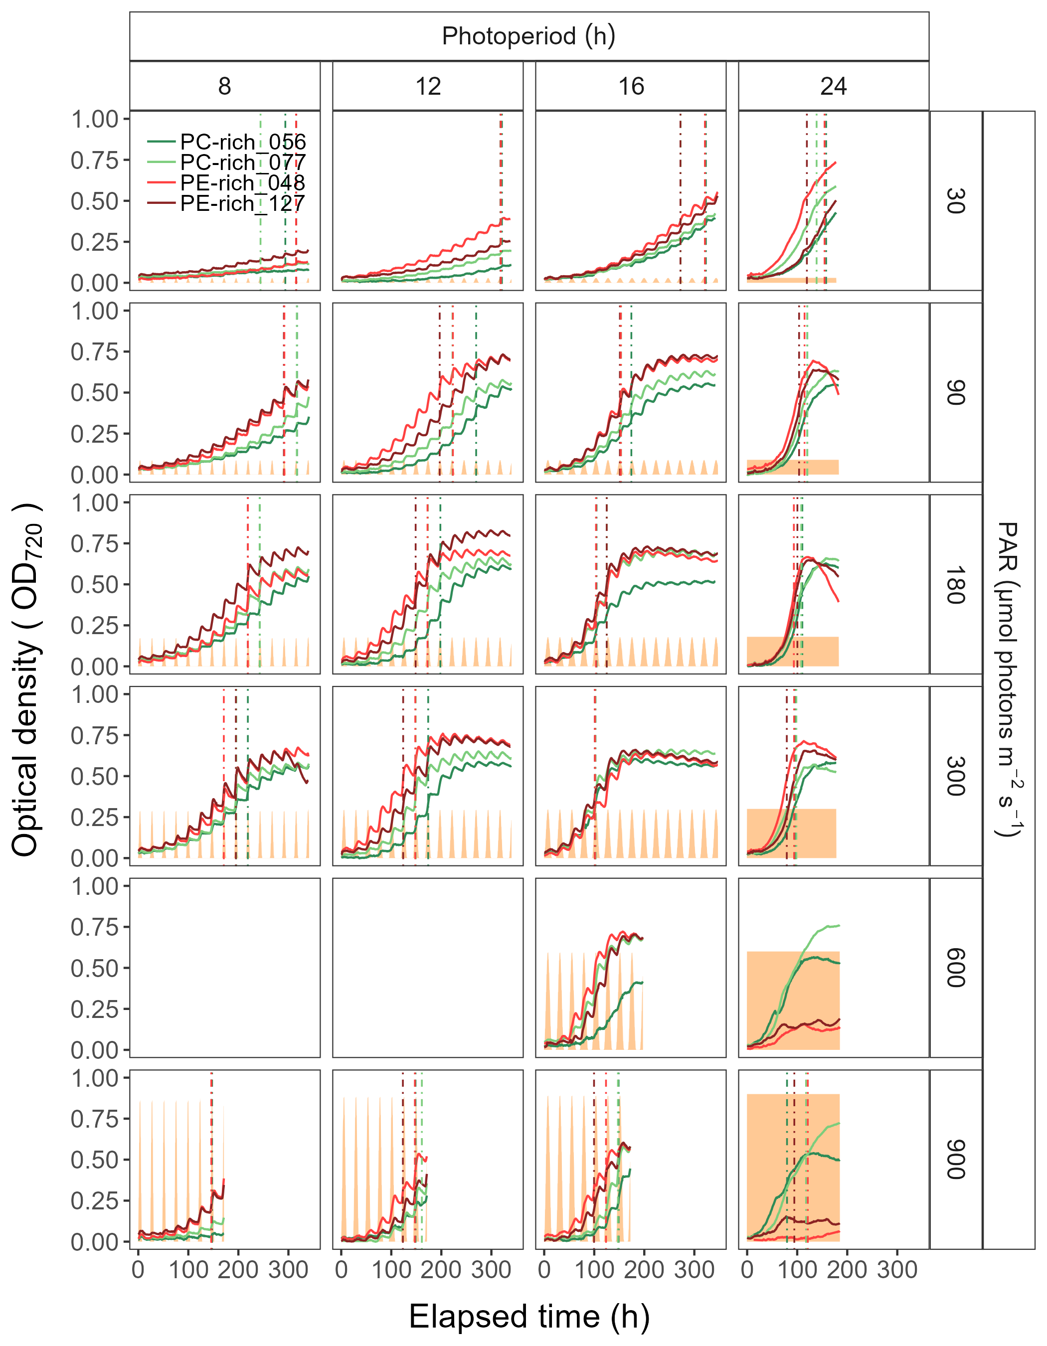

Figure 2: Example of representative growth curves (tracked as OD720) of two PhycoCyanin(PC)-rich cultures (light green line; 056, dark green line; 077) and two PhycoErythrin(PE)-rich cultures (light red line; 048, dark red line; 127) (Culture Collection of Baltic Algae) of *Synechococcus* sp. grown at 30, 90, 180, 300, or 900 peak PAR µmol photons m−2s−1; and photoperiods of 8, 12, 16, or 24 h. The vertical lines represent the time when the cultures reached their maximum absolute hourly growth (tMaxAG), taken as an index of transition from exponential to pre-stationary growth phases. The orange area represents the photoperiods, with peak PAR x 1/1000 to scale to the Y axis.

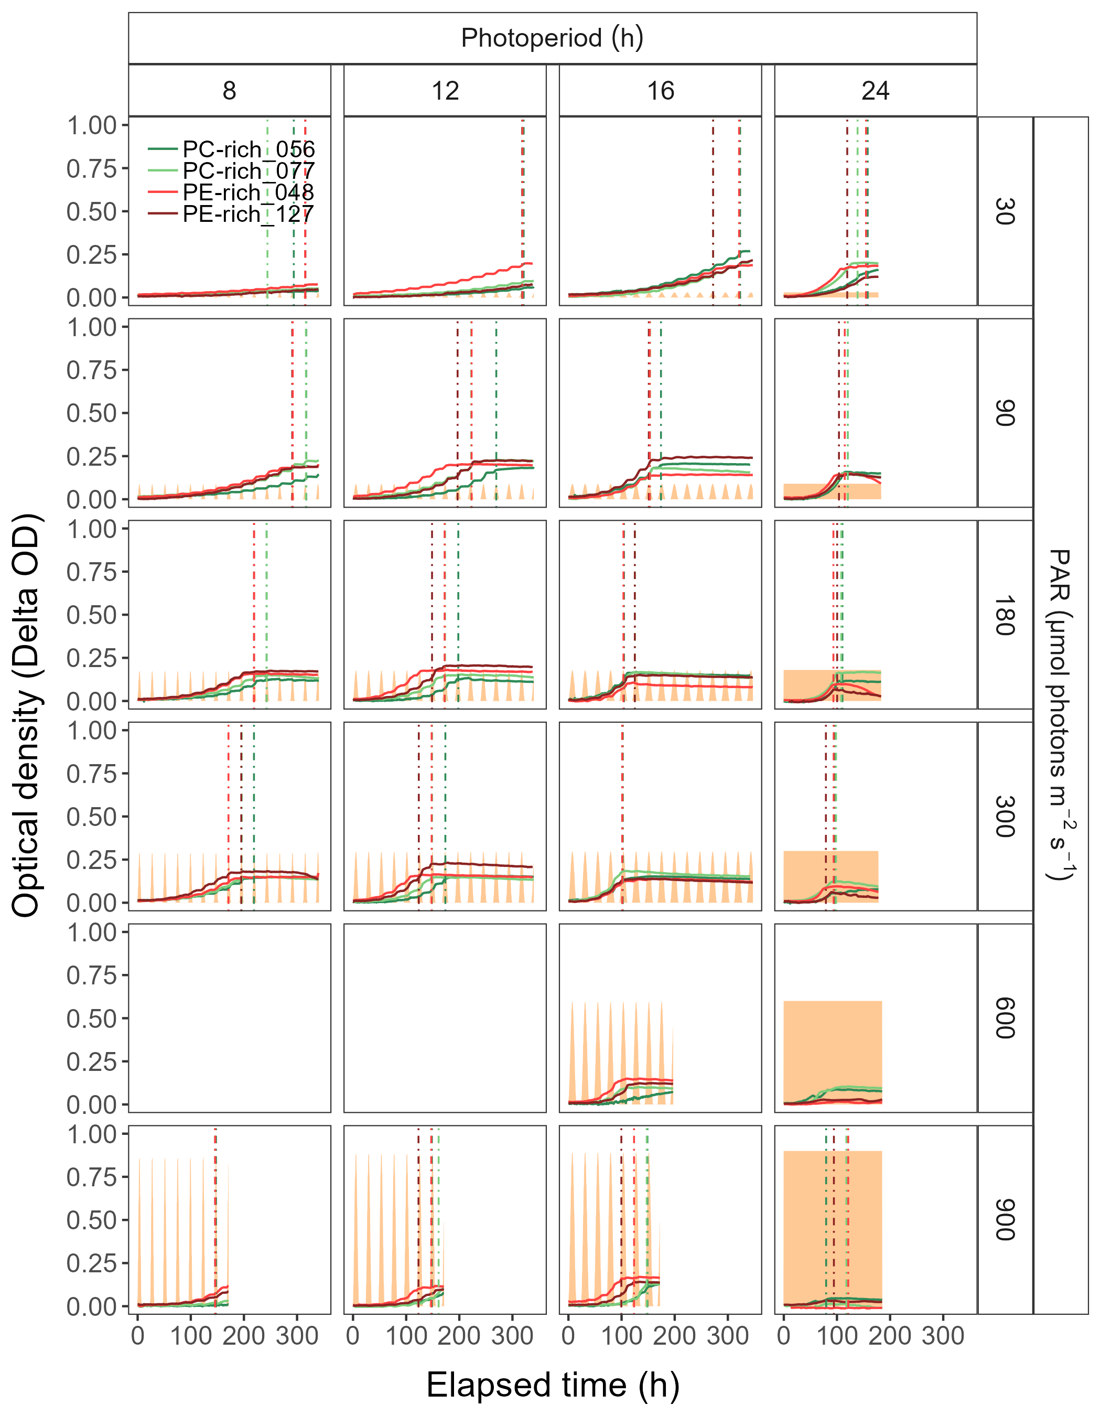

Figure 3: Example of representative growth curves (tracked as Delta OD) of two PhycoCyanin(PC)-rich cultures (light green line; 056, dark green line; 077) and two PhycoErythrin(PE)-rich cultures (light red line; 048, dark red line; 127) (Culture Collection of Baltic Algae) of *Synechococcus* sp. grown at 30, 90, 180, 300, or 900 peak PAR µmol photons m−2s−1; and photoperiods of 8, 12, 16, or 24 h. The vertical lines represent the time when the cultures reached their maximum absolute hourly growth (tMaxAG), taken as an index of transition from exponential to pre-stationary growth phases. The orange area represents the photoperiods, with peak PAR x 1/1000 to scale to the Y axis.

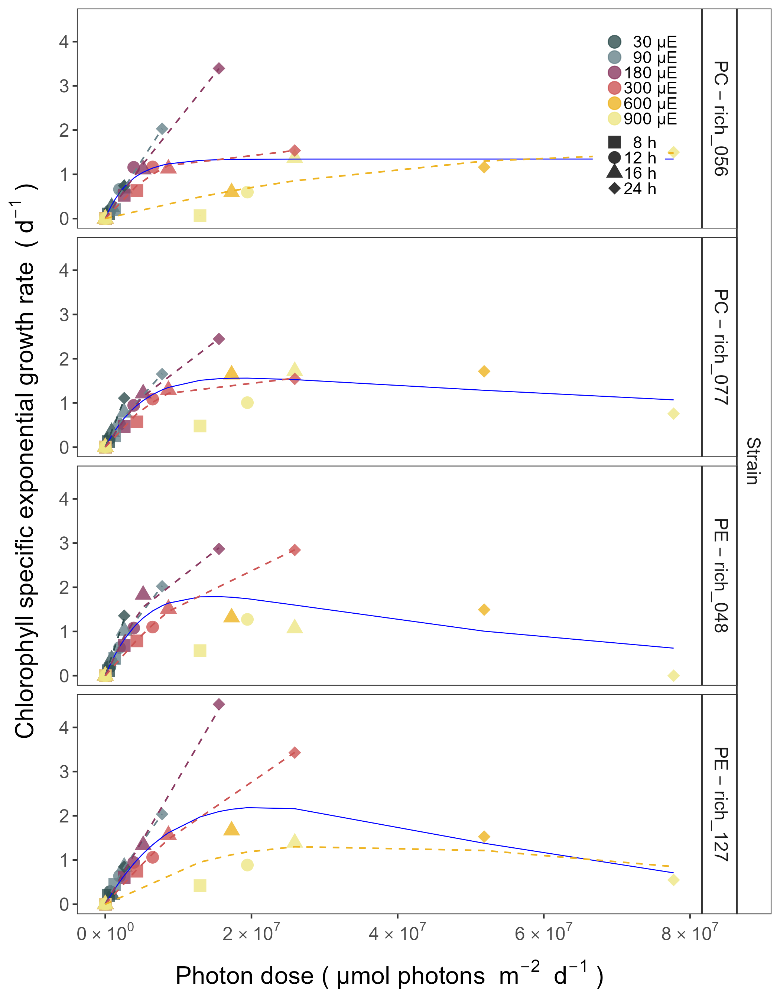

Figure 4: Chlorophyll specific exponential growth rates, estimated from logistic fits of chlorophyll proxy OD680-OD720 vs. elapsed time, for two PhycoCyanin(PC)-rich cultures (056, 077) and two PhycoErythrin(PE)-rich cultures (048, 127) (Culture Collection of Baltic Algae) of *Synechococcus* sp. grown at 30 (dark gray), 90 (light gray), 180 (purple), 300 (red), 600 (orange), or 900 (yellow) peak PAR µmol photons m−2s−1; and photoperiods of 8 (square), 12 (circle), 16 (triangle), or 24 (diamond) h. Growth rates (+/- SE from logistic model; SE falls within symbol sizes) are plotted vs. cumulative diel µmol photons m−2d−1. Solid blue line shows fit of the pooled data with a three parameter model (Harrison and Platt, 1986). We also fit the same model for chlorophyll specific exponential growth rate across 30 (dark gray), 90 (light gray), 180 (purple), 300 (red), 600 together with 900 (orange) peak PAR µmol photons m−2s−1, only when they were significantly different (ANOVA, *p* < 0.05) from the fit of pooled data.

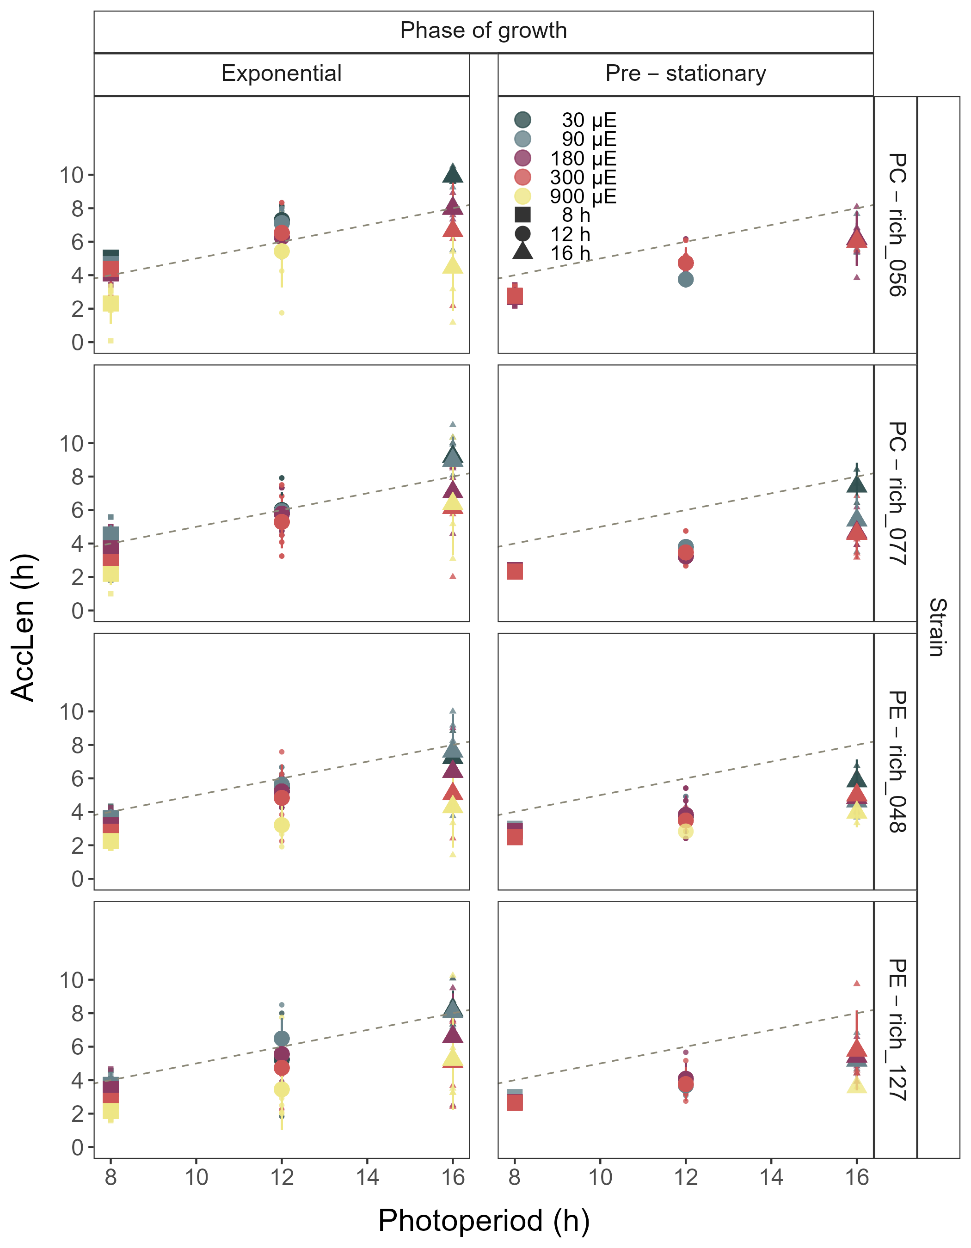

Figure 5: Hours of photoperiod to reach maximum hourly growth increment (AccLen), for two PhycoCyanin(PC)-rich cultures (056, 077) and two PhycoErythrin(PE)-rich cultures (048, 127) (Culture Collection of Baltic Algae) of *Synechococcus* sp. grown at 30 (dark gray), 90 (light gray), 180 (purple), 300 (red), or 900 (yellow) peak PAR µmol photons m−2s−1; and photoperiods of 8 (square), 12 (circle), or 16 (triangle) h. The diagonal dashed lines indicate the time (h) to reach the maximum light during the day. Figure represents all data (small symbols) and means (big symbols) for n = 0-5 days from exponential phase, or from pre-stationary growth phase.

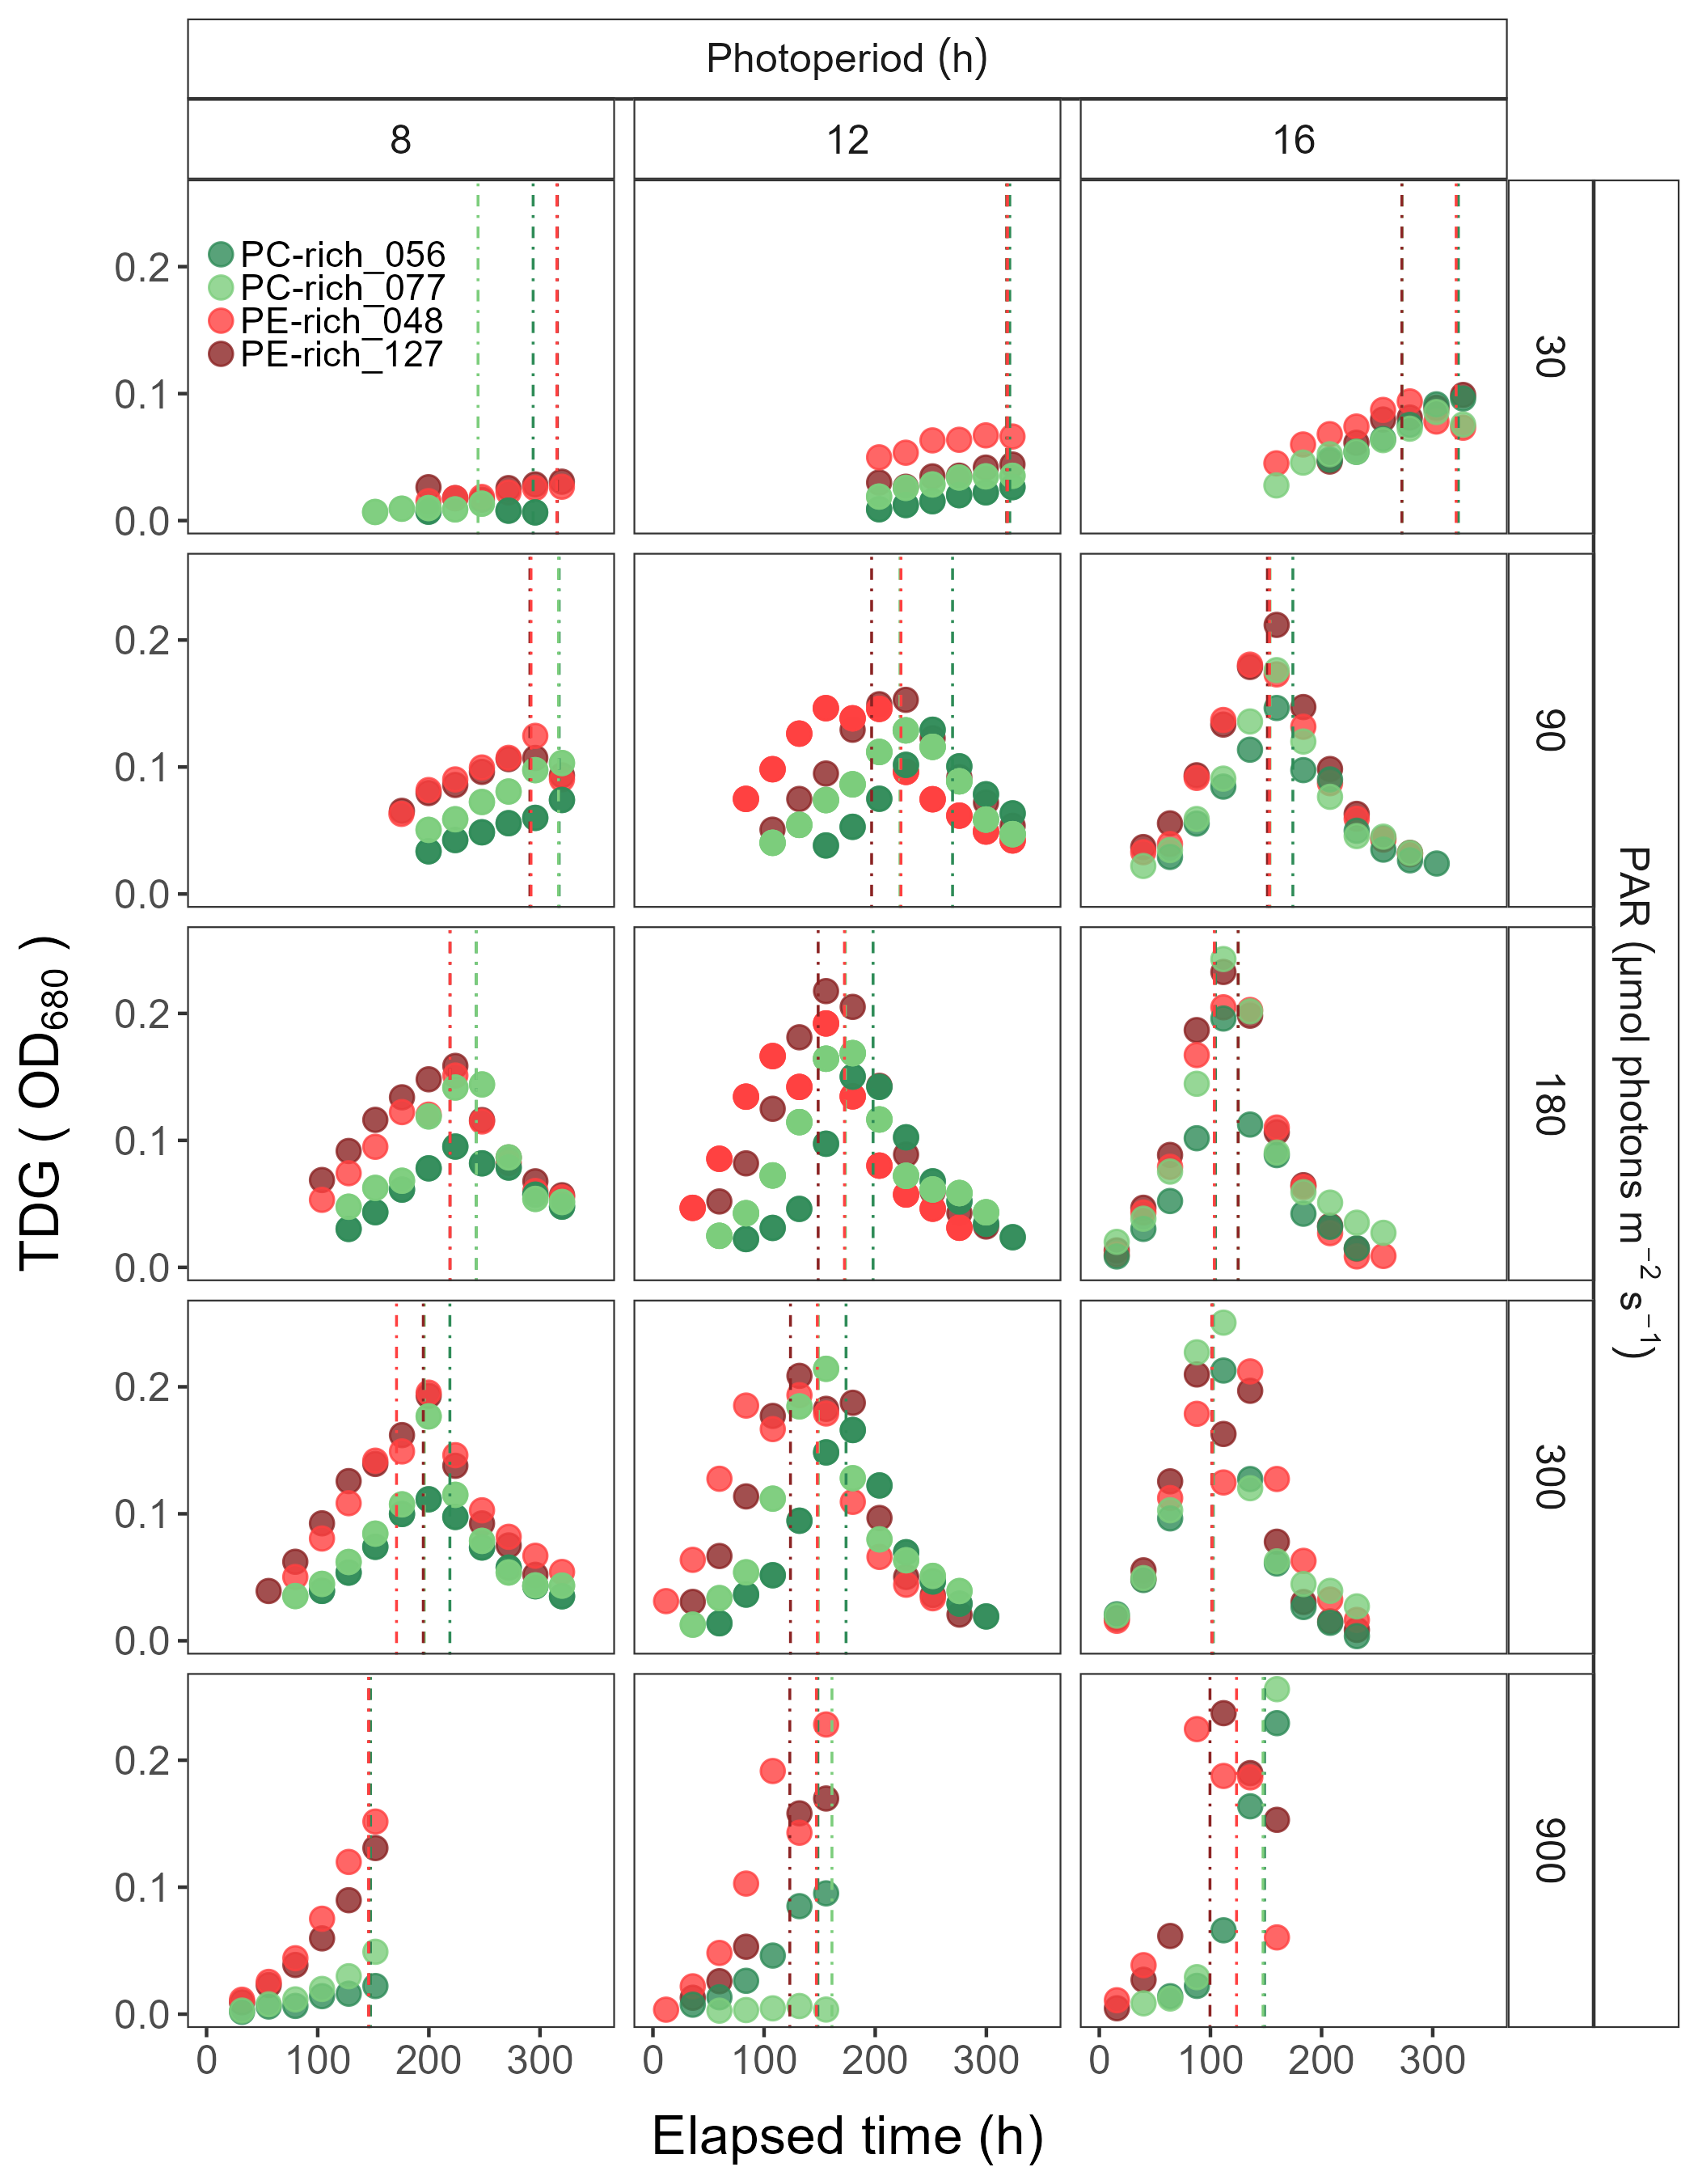

Figure 6: Changes of TDG (tracked as daily change in OD680 increment) of two PhycoCyanin(PC)-rich cultures (056, 077) and two PhycoErythrin(PE)-rich cultures (048, 127) (Culture Collection of Baltic Algae) of *Synechococcus* sp. grown at 30, 90, 180, 300, or 900 peak PAR µmol photons m−2s−1; and photoperiods of 8, 12, or 16 h. The vertical lines represent the time when the strains reached their maximum absolute hourly growth (tMaxAG).

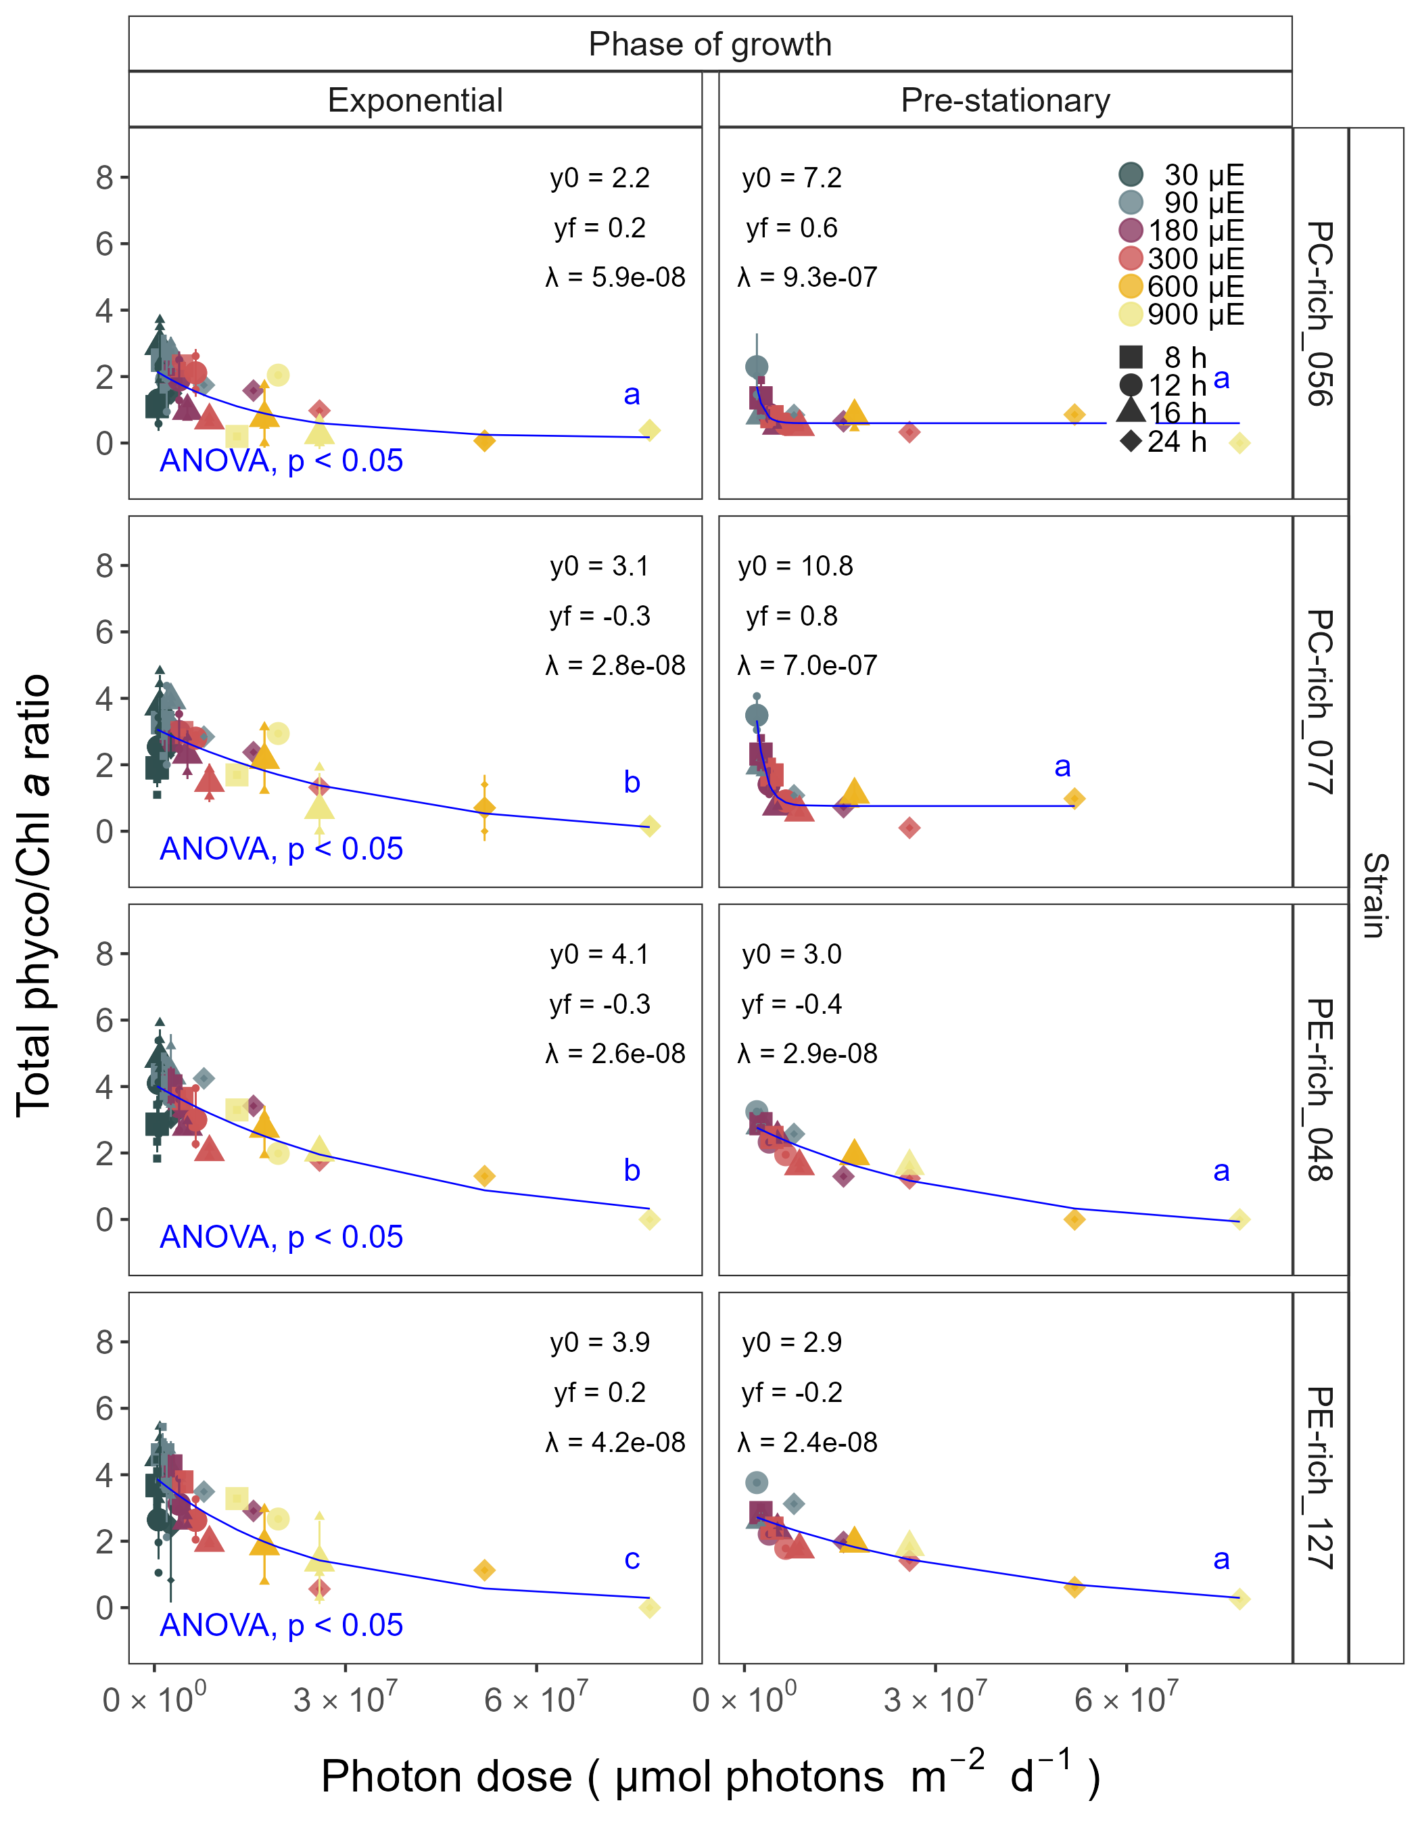

Figure 7: Changes of total Phyco/Chl *a* ratio of two PhycoCyanin(PC)-rich cultures (056, 077) and two PhycoErythrin(PE)-rich cultures (048, 127) (Culture Collection of Baltic Algae) of *Synechococcus* sp. grown at 30 (dark gray), 90 (light gray), 180 (purple), 300 (red), 600 (orange), or 900 (yellow) peak PAR µmol photons m−2s−1; and photoperiods of 8 (square), 12 (circle), 16 (triangle), or 24 (diamond) h. Figure represents all data (small symbols) and means (big symbols) from exponential phase, or from pre-stationary growth phase. Blue solid line shows single phase exponential decay fit of pooled data; fit parameters are presented. Different lowercase letters indicate significant differences between the fit models for strains for a given phase of growth (ANOVA; *p* < 0.05).

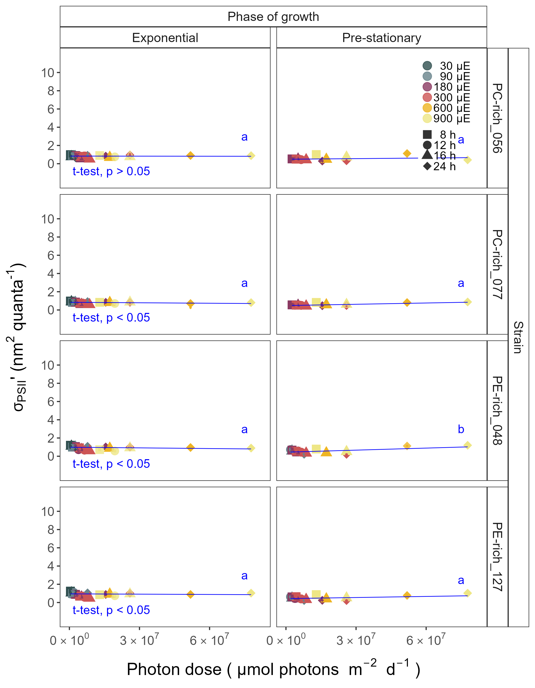

Figure 8: Effective absorption cross section of PSII (σPSII’; nm2 quanta-1) measured under diel peak PAR growth light under Ex445 nm (blue) excitation in two PhycoCyanin(PC)-rich cultures (056, 077) and two PhycoErythrin(PE)-rich cultures (048, 127) (Culture Collection of Baltic Algae) of *Synechococcus* sp. grown at 30 (dark gray), 90 (light gray), 180 (purple), 300 (red), 600 (orange), or 900 (yellow) peak PAR µmol photons m−2s−1; and photoperiods of 8 (square), 12 (circle), 16 (triangle), or 24 (diamond) h. Figure represents all data (small symbols) and means (big symbols) from exponential phase, or from pre-stationary growth phase. Blue solid line shows linear model fit.

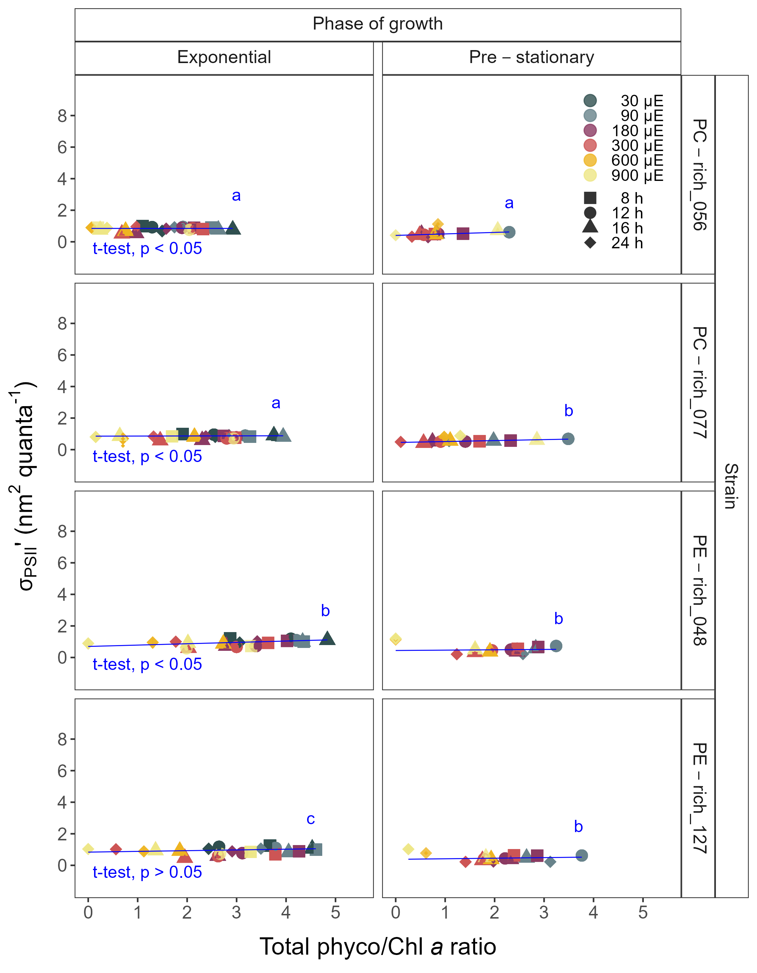

Figure 9: Changes of effective absorption cross section of PSII (σPSII’; nm2 quanta-1) measured under diel peak PAR growth light under Ex445 nm (blue) excitation in relation to the total Phyco/Chl *a* ratio of two PhycoCyanin(PC)-rich cultures (Culture Collection of Baltic Algae; 056, 077) and two PhycoErythrin(PE)-rich cultures (Culture Collection of Baltic Algae; 048, 127) of *Synechococcus* sp. grown at 30 (dark gray), 90 (light gray), 180 (purple), 300 (red), 600 (orange), or 900 (yellow) peak PAR µmol photons m−2s−1; and photoperiods of 8 (square), 12 (circle), 16 (triangle), or 24 (diamond) h. Figure represents all data (small symbols) and means (big symbols) from exponential phase, or from pre-stationary growth phase. Blue solid line shows linear model fit.

Table 1: Linear regression, coefficient of determination (R square), Pearson correlation coefficients (R), and p-value used to calculate the number of cells (N mL-1) of two PhycoCyanin(PC)-rich cultures (056, 077) and two PhycoErythrin(PE)-rich cultures (048, 127) (Culture Collection of Baltic Algae) of Synechococcus sp. based on optical density (OD) measurements.

| Strain | OD | Linear_regression | R_square | R | p_value |
| --- | --- | --- | --- | --- | --- |
| PC-rich_056 | 680 | N/mL = (OD680*160489)+34573 | 0.639 | 0.800 | 0.000 |
| PC-rich_077 | 680 | N/mL = (OD680*204581)+38483 | 0.831 | 0.910 | 0.000 |
| PE-rich_048 | 680 | N/mL = (OD680*450190)+14516 | 0.917 | 0.960 | 0.000 |
| PE-rich_127 | 680 | N/mL = (OD680*614649)+1446 | 0.885 | 0.940 | 0.000 |
| PC-rich_056 | 720 | N/mL = (OD720*218497)+34902 | 0.617 | 0.790 | 0.000 |
| PC-rich_077 | 720 | N/mL = (OD720*264482)+38766 | 0.828 | 0.910 | 0.000 |
| PE-rich_048 | 720 | N/mL = (OD720*600583)+14873 | 0.917 | 0.960 | 0.000 |
| PE-rich_127 | 720 | N/mL = (OD720*803505)+2786 | 0.879 | 0.940 | 0.000 |

Table 2: Linear regression, coefficient of determination (R square), Pearson correlation coefficients (R), and p-value used to calculate the pigment content (µg mL-1) of two PhycoCyanin(PC)-rich cultures (056, 077) and two PhycoErythrin(PE)-rich cultures (048, 127) (Culture Collection of Baltic Algae) of Synechococcus sp. based on absorbance (Abs) measurements.

| Pigment | Abs | Linear_regression | R_square | R | p_value |
| --- | --- | --- | --- | --- | --- |
| Chl a | 665 | Chla µg/mL = (Abs665*13.411029)+0.154793 | 0.865 | 0.930 | 0.000 |
| Car | 480 | Car µg/mL = (Abs480*5.469880)+0.089971 | 0.791 | 0.890 | 0.000 |
| PE | 565 | PE µg/mL = (Abs565*26.760737)-0.143872 | 0.698 | 0.840 | 0.000 |
| PC | 620 | PC µg/mL = (Abs620*29.979866)-0.182611 | 0.807 | 0.900 | 0.000 |
| APC | 650 | APC µg/mL = (Abs650*3.873803)+0.021964 | 0.087 | 0.300 | 0.000 |

Table 3: Three-way factorial ANOVA of chlorophyll specific exponential growth rate (Source_of_variation), estimated from logistic fits of chlorophyll proxy OD680-OD720 vs. elapsed time, for two PhycoCyanin(PC)-rich cultures (056, 077) and two PhycoErythrin(PE)-rich cultures (048, 127) (Culture Collection of Baltic Algae) of Synechococcus sp., grown at 30, 90, 180, 300, 600, or 900 peak PAR µmol photons m−2s−1; and photoperiods of 8, 12, 16, or 24 h. Df – degrees of freedom; Sum Sq – sum of squares; Mean Sq – mean sum of squares; F_value – Fisher's F-test statistic; p_value - level of significance.

| Source_of_variation | Df | Sum Sq | Mean Sq | F_value | p_value |
| --- | --- | --- | --- | --- | --- |
| Par_ue | 5 | 0.049 | 0.010 | 3.276e+30 | 0.000 |
| Photoperiod | 3 | 0.076 | 0.025 | 8.367e+30 | 0.000 |
| Strain | 3 | 0.003 | 0.001 | 3.151e+29 | 0.000 |
| Par_ue:Photoperiod | 13 | 0.040 | 0.003 | 1.025e+30 | 0.000 |
| Par_ue:Strain | 15 | 0.007 | 0.000 | 1.593e+29 | 0.000 |
| Photoperiod:Strain | 9 | 0.004 | 0.000 | 1.306e+29 | 0.000 |
| Par_ue:Photoperiod:Strain | 39 | 0.017 | 0.000 | 1.434e+29 | 0.000 |
| Residuals | 88 | 0.000 | 0.000 | NA | N/A |

Table 4: One-way ANOVA of a three parameter model (Harrison and Platt, 1986) (Fit_model) from pooled data (All) and data fit across different photoperiods (8, 12, 16, or 24) from chlorophyll specific exponential growth rate, for two PhycoCyanin(PC)-rich cultures (056, 077) and two PhycoErythrin(PE)-rich cultures (048, 127) (Culture Collection of Baltic Algae) of Synechococcus sp., grown at 30, 90, 180, 300, 600, or 900 peak PAR µmol photons m−2s−1; and photoperiods of 8, 12, 16, or 24 h. Res.Df - residual degrees of freedom for each model; Res.Sum Sq - residual sum of squares for each model; F_value – Fisher's F-test statistic; p_value - level of significance.

| Strain | Fit_model | Res.Df | Res.Sum Sq | F_value | p_value |
| --- | --- | --- | --- | --- | --- |
| PC-rich_056 | 8_All | 41 | 7.983 | 2.072e+03 | 0.000 |
| PC-rich_056 | 12_All | 41 | 7.983 | 2.715e+01 | 0.001 |
| PC-rich_056 | 16_All | 41 | 7.983 | 1.449e+01 | 0.004 |
| PC-rich_056 | 24_All | 41 | 7.983 | 2.463e+01 | 0.001 |
| PC-rich_077 | 8_All | 41 | 3.093 | 5.189e+01 | 0.000 |
| PC-rich_077 | 12_All | 41 | 3.093 | 2.147e+01 | 0.001 |
| PC-rich_077 | 16_All | 41 | 3.093 | 1.365e+01 | 0.004 |
| PC-rich_077 | 24_All | 41 | 3.093 | 9.767e+00 | 0.009 |
| PE-rich_048 | 8_All | 41 | 6.645 | 2.833e+01 | 0.001 |
| PE-rich_048 | 12_All | 41 | 6.645 | 3.520e+01 | 0.000 |
| PE-rich_048 | 16_All | 41 | 6.645 | 6.487e+00 | 0.023 |
| PE-rich_048 | 24_All | 41 | 6.645 | 1.415e+02 | 0.000 |
| PE-rich_127 | 8_All | 41 | 13.041 | 1.425e+02 | 0.000 |
| PE-rich_127 | 12_All | 41 | 13.041 | 1.467e+04 | 0.000 |
| PE-rich_127 | 16_All | 41 | 13.041 | 2.334e+01 | 0.001 |
| PE-rich_127 | 24_All | 41 | 13.041 | 1.129e+02 | 0.000 |

Table 5: One-way ANOVA of a three parameter model (Harrison and Platt, 1986) (Fit_model) from pooled data (All) and data fit across different peak PAR (30, 90, 180, 300, 600 together with 900) from chlorophyll specific exponential growth rate, for two PhycoCyanin(PC)-rich cultures (056, 077) and two PhycoErythrin(PE)-rich cultures (048, 127) (Culture Collection of Baltic Algae) of Synechococcus sp., grown at 30, 90, 180, 300, 600, or 900 peak PAR µmol photons m−2s−1; and photoperiods of 8, 12, 16, or 24 h. Res.Df - residual degrees of freedom for each model; Res.Sum Sq - residual sum of squares for each model; F_value – Fisher's F-test statistic; p_value - level of significance.

| Strain | Fit_model | Res.Df | Res.Sum Sq | F_value | p_value |
| --- | --- | --- | --- | --- | --- |
| PC-rich_056 | 30_All | 41 | 7.983 | 2.072e+03 | 0.000 |
| PC-rich_056 | 90_All | 41 | 7.983 | 2.715e+01 | 0.001 |
| PC-rich_056 | 180_All | 41 | 7.983 | 1.449e+01 | 0.004 |
| PC-rich_056 | 300_All | 41 | 7.983 | 2.463e+01 | 0.001 |
| PC-rich_056 | 900_All | 41 | 7.983 | 4.490e+00 | 0.011 |
| PC-rich_077 | 30_All | 41 | 3.093 | 5.189e+01 | 0.000 |
| PC-rich_077 | 90_All | 41 | 3.093 | 2.147e+01 | 0.001 |
| PC-rich_077 | 180_All | 41 | 3.093 | 1.365e+01 | 0.004 |
| PC-rich_077 | 300_All | 41 | 3.093 | 9.767e+00 | 0.009 |
| PC-rich_077 | 900_All | 41 | 3.093 | 7.909e-01 | 0.706 |
| PE-rich_048 | 30_All | 41 | 6.645 | 2.833e+01 | 0.001 |
| PE-rich_048 | 90_All | 41 | 6.645 | 3.520e+01 | 0.000 |
| PE-rich_048 | 180_All | 41 | 6.645 | 6.487e+00 | 0.023 |
| PE-rich_048 | 300_All | 41 | 6.645 | 1.415e+02 | 0.000 |
| PE-rich_048 | 900_All | 41 | 6.645 | 1.922e+00 | 0.151 |
| PE-rich_127 | 30_All | 41 | 13.041 | 1.425e+02 | 0.000 |
| PE-rich_127 | 90_All | 41 | 13.041 | 1.467e+04 | 0.000 |
| PE-rich_127 | 180_All | 41 | 13.041 | 2.334e+01 | 0.001 |
| PE-rich_127 | 300_All | 41 | 13.041 | 1.129e+02 | 0.000 |
| PE-rich_127 | 900_All | 41 | 13.041 | 3.938e+00 | 0.018 |

Table 6: Three-way factorial ANOVA of index of diel growth symmetry; AccLen/DecLen ratio (Source_of_variation), for two PhycoCyanin(PC)-rich cultures (056, 077) and two PhycoErythrin(PE)-rich cultures (048, 127) (Culture Collection of Baltic Algae) of Synechococcus sp., grown at 30, 90, 180, 300, or 900 peak PAR µmol photons m−2s−1; and photoperiods of 8, 12, or 16 h. Df – degrees of freedom; Sum Sq – sum of squares; Mean Sq – mean sum of squares; F_value – Fisher's F-test statistic; p_value - level of significance.

| Source_of_variation | Df | Sum Sq | Mean Sq | F_value | p_value |
| --- | --- | --- | --- | --- | --- |
| PhotonDose_day | 13 | 68.718 | 5.286 | 3.216e+01 | 0.000 |
| Phase | 1 | 40.423 | 40.423 | 2.459e+02 | 0.000 |
| Strain | 3 | 26.578 | 8.859 | 5.390e+01 | 0.000 |
| PhotonDose_day:Phase | 10 | 3.648 | 0.365 | 2.219e+00 | 0.015 |
| PhotonDose_day:Strain | 39 | 19.872 | 0.510 | 3.100e+00 | 0.000 |
| Phase:Strain | 3 | 2.569 | 0.856 | 5.209e+00 | 0.001 |
| PhotonDose_day:Phase:Strain | 21 | 2.814 | 0.134 | 8.154e-01 | 0.702 |
| Residuals | 624 | 102.568 | 0.164 | NA | N/A |

Table 7: One-way ANOVA of single phase exponential decay fit model (Fit_model) of pooled data across different strains for a given phase of growth (exponential; _Exp, pre-stationary; _St) and across different phase of growth for a given strain (_Exp_St) from index of diel growth symmetry; AccLen/DecLen ratio, for two PhycoCyanin(PC)-rich cultures (056, 077) and two PhycoErythrin(PE)-rich cultures (048, 127) (Culture Collection of Baltic Algae) of Synechococcus sp., grown at 30, 90, 180, 300, or 900 peak PAR µmol photons m−2s−1; and photoperiods of 8, 12, or 16 h. Res.Df - residual degrees of freedom for each model; Res.Sum Sq - residual sum of squares for each model; F_value – Fisher's F-test statistic; p_value - level of significance.

| Fit_model | Res.Df | Res.Sum Sq | F_value | p_value |
| --- | --- | --- | --- | --- |
| 056_077_Exp | 153 | 45.134 | 9.146e-01 | 0.593 |
| 048_127_Exp | 83 | 23.188 | -1.792e+00 | 1.000 |
| 056_048_Exp | 108 | 10.675 | 1.594e+01 | 0.000 |
| 077_048_Exp | 108 | 10.675 | 7.747e+00 | 0.000 |
| 056_127_Exp | 83 | 23.188 | 1.216e+00 | 0.222 |
| 077_127_Exp | 83 | 23.188 | 1.122e+00 | 0.306 |
| 056_077_St | 76 | 1.281 | -8.049e-01 | 1.000 |
| 048_127_St | 34 | 0.718 | 1.743e+00 | 0.061 |
| 056_048_St | 50 | 2.203 | -8.588e-01 | 1.000 |
| 077_048_St | 62 | 1.749 | -1.185e+00 | 1.000 |
| 056_127_St | 34 | 0.718 | 4.395e+00 | 0.000 |
| 077_127_St | 34 | 0.718 | 6.346e-01 | 0.919 |
| 056_Exp_St | 50 | 2.203 | 1.067e+01 | 0.000 |
| 077_Exp_St | 76 | 1.281 | 3.379e+01 | 0.000 |
| 048_Exp_St | 62 | 1.749 | 6.879e+00 | 0.000 |
| 127_Exp_St | 34 | 0.718 | 2.171e+01 | 0.000 |

Table 8: Three-way factorial ANOVA of PUR/PAR ratio (Source_of_variation), for two PhycoCyanin(PC)-rich cultures (056, 077) and two PhycoErythrin(PE)-rich cultures (048, 127) (Culture Collection of Baltic Algae) of Synechococcus sp., grown at 30, 90, 180, 300, 600, or 900 peak PAR µmol photons m−2s−1; and photoperiods of 8, 12, 16, or 24 h. Df – degrees of freedom; Sum Sq – sum of squares; Mean Sq – mean sum of squares; F_value – Fisher's F-test statistic; p_value - level of significance.

| Source_of_variation | Df | Sum Sq | Mean Sq | F_value | p_value |
| --- | --- | --- | --- | --- | --- |
| PhotonDose_day | 18 | 1.901 | 0.106 | 4.157e+01 | 0.000 |
| Phase | 1 | 0.334 | 0.334 | 1.314e+02 | 0.000 |
| Strain | 3 | 1.991 | 0.664 | 2.614e+02 | 0.000 |
| PhotonDose_day:Phase | 12 | 0.036 | 0.003 | 1.175e+00 | 0.305 |
| PhotonDose_day:Strain | 52 | 0.623 | 0.012 | 4.720e+00 | 0.000 |
| Phase:Strain | 3 | 0.028 | 0.009 | 3.723e+00 | 0.013 |
| PhotonDose_day:Phase:Strain | 13 | 0.016 | 0.001 | 4.994e-01 | 0.922 |
| Residuals | 159 | 0.404 | 0.003 | NA | N/A |

Table 9: One-way ANOVA of single phase exponential decay fit model (Fit_model) of pooled data across different strains for a given phase of growth (exponential; _Exp, pre-stationary; _St) and across different phase of growth for a given strain (_Exp_St) from PUR/PAR ratio, for two PhycoCyanin(PC)-rich cultures (056, 077) and two PhycoErythrin(PE)-rich cultures (048, 127) (Culture Collection of Baltic Algae) of Synechococcus sp., grown at 30, 90, 180, 300, 600, or 900 peak PAR µmol photons m−2s−1; and photoperiods of 8, 12, 16, or 24 h. Res.Df - residual degrees of freedom for each model; Res.Sum Sq - residual sum of squares for each model; F_value – Fisher's F-test statistic; p_value - level of significance.

| Fit_model | Res.Df | Res.Sum Sq | F_value | p_value |
| --- | --- | --- | --- | --- |
| 056_077_Exp | 43 | 0.025 | 2.813e+01 | 0.000 |
| 048_127_Exp | 51 | 0.217 | NA | N/A |
| 056_048_Exp | 51 | 0.307 | 2.762e+01 | 0.000 |
| 077_048_Exp | 51 | 0.307 | 5.976e+01 | 0.000 |
| 056_127_Exp | 51 | 0.217 | 1.607e+01 | 0.000 |
| 077_127_Exp | 51 | 0.217 | 4.064e+01 | 0.000 |
| 056_077_St | 20 | 0.006 | -1.491e-01 | 1.000 |
| 048_127_St | 2 | 0.000 | 5.386e+00 | 0.168 |
| 056_048_St | 17 | 0.009 | 9.648e-02 | 0.999 |
| 077_048_St | 17 | 0.009 | -2.066e+00 | 1.000 |
| 056_127_St | 2 | 0.000 | 1.415e+01 | 0.067 |
| 077_127_St | 2 | 0.000 | 2.812e+00 | 0.294 |
| 056_Exp_St | 7 | 0.008 | 1.882e+00 | 0.195 |
| 077_Exp_St | 20 | 0.006 | 3.039e+00 | 0.007 |
| 048_Exp_St | 17 | 0.009 | 1.681e+01 | 0.000 |
| 127_Exp_St | 2 | 0.000 | 4.128e+01 | 0.024 |

Table 10: Three-way factorial ANOVA of total Phyco/Chl a ratio (Source_of_variation), for two PhycoCyanin(PC)-rich cultures (056, 077) and two PhycoErythrin(PE)-rich cultures (048, 127) (Culture Collection of Baltic Algae) of Synechococcus sp., grown at 30, 90, 180, 300, 600, or 900 peak PAR µmol photons m−2s−1; and photoperiods of 8, 12, 16, or 24 h. Df – degrees of freedom; Sum Sq – sum of squares; Mean Sq – mean sum of squares; F_value – Fisher's F-test statistic; p_value - level of significance.

| Source_of_variation | Df | Sum Sq | Mean Sq | F_value | p_value |
| --- | --- | --- | --- | --- | --- |
| PhotonDose_day | 18 | 262.901 | 14.606 | 2.885e+01 | 0.000 |
| Phase | 1 | 36.951 | 36.951 | 7.299e+01 | 0.000 |
| Strain | 3 | 126.558 | 42.186 | 8.332e+01 | 0.000 |
| PhotonDose_day:Phase | 12 | 9.647 | 0.804 | 1.588e+00 | 0.098 |
| PhotonDose_day:Strain | 54 | 27.834 | 0.515 | 1.018e+00 | 0.451 |
| Phase:Strain | 3 | 2.600 | 0.867 | 1.712e+00 | 0.166 |
| PhotonDose_day:Phase:Strain | 35 | 6.101 | 0.174 | 3.443e-01 | 1.000 |
| Residuals | 185 | 93.662 | 0.506 | NA | N/A |

Table 11: One-way ANOVA of single phase exponential decay fit model (Fit_model) of pooled data across different strains for a given phase of growth (exponential; _Exp, pre-stationary; _St) and across different phase of growth for a given strain (_Exp_St) from total Phyco/Chl a ratio, for two PhycoCyanin(PC)-rich cultures (056, 077) and two PhycoErythrin(PE)-rich cultures (048, 127) (Culture Collection of Baltic Algae) of Synechococcus sp., grown at 30, 90, 180, 300, 600, or 900 peak PAR µmol photons m−2s−1; and photoperiods of 8, 12, 16, or 24 h. Res.Df - residual degrees of freedom for each model; Res.Sum Sq - residual sum of squares for each model; F_value – Fisher's F-test statistic; p_value - level of significance.

| Fit_model | Res.Df | Res.Sum Sq | F_value | p_value |
| --- | --- | --- | --- | --- |
| 056_077_Exp | 49 | 38.089 | 1.531e+01 | 0.000 |
| 048_127_Exp | 52 | 54.559 | NA | N/A |
| 056_048_Exp | 52 | 39.302 | 4.333e+00 | 0.005 |
| 077_048_Exp | 52 | 39.302 | 5.202e-01 | 0.670 |
| 056_127_Exp | 52 | 54.559 | 1.067e+01 | 0.000 |
| 077_127_Exp | 52 | 54.559 | 7.063e+00 | 0.000 |
| 056_077_St | 24 | 3.580 | -1.005e+01 | 1.000 |
| 048_127_St | 19 | 3.343 | NA | N/A |
| 056_048_St | 19 | 2.239 | -2.229e-01 | 1.000 |
| 077_048_St | 19 | 2.239 | 2.276e+00 | 0.088 |
| 056_127_St | 19 | 3.343 | -1.195e+00 | 1.000 |
| 077_127_St | 19 | 3.343 | 2.686e-01 | 0.925 |
| 056_Exp_St | 25 | 2.081 | 1.399e+01 | 0.000 |
| 077_Exp_St | 24 | 3.580 | 9.255e+00 | 0.000 |
| 048_Exp_St | 19 | 2.239 | 9.531e+00 | 0.000 |
| 127_Exp_St | 19 | 3.343 | 8.820e+00 | 0.000 |

Table 12: Three-way factorial ANOVA of effective absorption cross section of PSII (σPSII’; nm2 quanta-1) measured under diel peak PAR growth light under Ex445 nm (blue) excitation (Source_of_variation), for two PhycoCyanin(PC)-rich cultures (056, 077) and two PhycoErythrin(PE)-rich cultures (048, 127) (Culture Collection of Baltic Algae) of Synechococcus sp., grown at 30, 90, 180, 300, 600, or 900 peak PAR µmol photons m−2s−1; and photoperiods of 8, 12, 16, or 24 h. Df – degrees of freedom; Sum Sq – sum of squares; Mean Sq – mean sum of squares; F_value – Fisher's F-test statistic; p_value - level of significance.

| Source_of_variation | Df | Sum Sq | Mean Sq | F_value | p_value |
| --- | --- | --- | --- | --- | --- |
| PhotonDose_day | 18 | 31.956 | 1.775 | 2.140e+02 | 0.000 |
| Phase | 1 | 15.718 | 15.718 | 1.894e+03 | 0.000 |
| Strain | 3 | 1.086 | 0.362 | 4.361e+01 | 0.000 |
| PhotonDose_day:Phase | 13 | 5.727 | 0.441 | 5.309e+01 | 0.000 |
| PhotonDose_day:Strain | 54 | 4.330 | 0.080 | 9.663e+00 | 0.000 |
| Phase:Strain | 3 | 0.296 | 0.099 | 1.189e+01 | 0.000 |
| PhotonDose_day:Phase:Strain | 34 | 1.710 | 0.050 | 6.063e+00 | 0.000 |
| Residuals | 856 | 7.103 | 0.008 | NA | N/A |

Table 13: T-test of linear fit model (Fit_model) of pooled data across different strains for a given phase of growth (exponential; _Exp, pre-stationary; _St) and across different phase of growth for a given strain (_Exp_St) from effective absorption cross section of PSII (σPSII’; nm2 quanta-1) measured under diel peak PAR growth light under Ex445 nm (blue) excitation, for two PhycoCyanin(PC)-rich cultures (056, 077) and two PhycoErythrin(PE)-rich cultures (048, 127) (Culture Collection of Baltic Algae) of Synechococcus sp., grown at 30, 90, 180, 300, 600, or 900 peak PAR µmol photons m−2s−1; and photoperiods of 8, 12, 16, or 24 h. Estimate - estimation statistics; Std.Error - standard error of the estimate; t_value – t-test statistic; p_value - level of significance.

| Fit_model | Estimate | Std.Error | t_value | p_value |
| --- | --- | --- | --- | --- |
| 056_077_Exp | -1.451e-09 | 1.058e-09 | -1.372 | 0.171 |
| 056_048_Exp | -2.188e-09 | 1.313e-09 | -1.666 | 0.097 |
| 056_127_Exp | -8.236e-10 | 1.412e-09 | -0.583 | 0.560 |
| 048_127_Exp | 1.365e-09 | 1.603e-09 | 0.851 | 0.395 |
| 077_048_Exp | -7.373e-10 | 1.233e-09 | -0.598 | 0.550 |
| 077_127_Exp | 6.274e-10 | 1.336e-09 | 0.470 | 0.639 |
| 056_077_St | 2.453e-09 | 1.349e-09 | 1.818 | 0.071 |
| 056_048_St | 5.254e-09 | 2.098e-09 | 2.505 | 0.014 |
| 056_127_St | 1.745e-09 | 1.862e-09 | 0.937 | 0.350 |
| 048_127_St | -3.509e-09 | 1.658e-09 | -2.116 | 0.036 |
| 077_048_St | 2.801e-09 | 1.263e-09 | 2.217 | 0.028 |
| 077_127_St | -7.077e-10 | 1.209e-09 | -0.586 | 0.559 |
| 056_Exp_St | 2.487e-09 | 1.643e-09 | 1.514 | 0.132 |
| 077_Exp_St | 6.391e-09 | 9.166e-10 | 6.973 | 0.000 |
| 048_Exp_St | 9.930e-09 | 1.695e-09 | 5.860 | 0.000 |
| 127_Exp_St | 5.056e-09 | 1.621e-09 | 3.120 | 0.002 |

Table 14: Three-way factorial ANOVA of effective absorption cross section of PSII (σPSII’; nm2 quanta-1) measured under diel peak PAR growth light under Ex590 nm (orange) excitation (Source_of_variation), for two PhycoCyanin(PC)-rich cultures (056, 077) and two PhycoErythrin(PE)-rich cultures (048, 127) (Culture Collection of Baltic Algae) of Synechococcus sp., grown at 30, 90, 180, 300, 600, or 900 peak PAR µmol photons m−2s−1; and photoperiods of 8, 12, 16, or 24 h. Df – degrees of freedom; Sum Sq – sum of squares; Mean Sq – mean sum of squares; F_value – Fisher's F-test statistic; p_value - level of significance.

| Source_of_variation | Df | Sum Sq | Mean Sq | F_value | p_value |
| --- | --- | --- | --- | --- | --- |
| PhotonDose_day | 15 | 1,101.207 | 73.414 | 1.351e+02 | 0.000 |
| Phase | 1 | 177.130 | 177.130 | 3.259e+02 | 0.000 |
| Strain | 3 | 445.771 | 148.590 | 2.734e+02 | 0.000 |
| PhotonDose_day:Phase | 12 | 81.052 | 6.754 | 1.243e+01 | 0.000 |
| PhotonDose_day:Strain | 43 | 137.289 | 3.193 | 5.874e+00 | 0.000 |
| Phase:Strain | 3 | 29.057 | 9.686 | 1.782e+01 | 0.000 |
| PhotonDose_day:Phase:Strain | 12 | 17.653 | 1.471 | 2.707e+00 | 0.002 |
| Residuals | 446 | 242.409 | 0.544 | NA | N/A |

Table 15: One-way ANOVA of single phase exponential decay fit model (Fit_model) of pooled data across different strains for a given phase of growth (exponential; _Exp, pre-stationary; _St) and across different phase of growth for a given strain (_Exp_St) from effective absorption cross section of PSII (σPSII’; nm2 quanta-1) measured under diel peak PAR growth light under Ex590 nm (orange) excitation, for two PhycoCyanin(PC)-rich cultures (056, 077) and two PhycoErythrin(PE)-rich cultures (048, 127) (Culture Collection of Baltic Algae) of Synechococcus sp., grown at 30, 90, 180, 300, 600, or 900 peak PAR µmol photons m−2s−1; and photoperiods of 8, 12, 16, or 24 h. Res.Df - residual degrees of freedom for each model; Res.Sum Sq - residual sum of squares for each model; F_value – Fisher's F-test statistic; p_value - level of significance.

| Fit_model | Res.Df | Res.Sum Sq | F_value | p_value |
| --- | --- | --- | --- | --- |
| 056_077_Exp | 97 | 116.359 | 9.926e-01 | 0.469 |
| 048_127_Exp | 72 | 106.728 | -1.652e+00 | 1.000 |
| 056_048_Exp | 97 | 116.359 | 3.764e+01 | 0.000 |
| 077_048_Exp | 112 | 134.219 | 8.037e+00 | 0.000 |
| 056_127_Exp | 72 | 106.728 | 2.599e-01 | 1.000 |
| 077_127_Exp | 72 | 106.728 | 4.636e-01 | 0.995 |
| 056_077_St | 41 | 3.366 | 1.522e+01 | 0.000 |
| 048_127_St | 45 | 38.775 | 3.762e+00 | 0.001 |
| 056_048_St | 34 | 17.489 | 1.158e+02 | 0.000 |
| 077_048_St | 34 | 17.489 | -3.922e+00 | 1.000 |
| 056_127_St | 45 | 38.775 | 1.566e+02 | 0.000 |
| 077_127_St | 45 | 38.775 | 1.078e+02 | 0.000 |
| 056_Exp_St | 17 | 0.150 | 1.650e+02 | 0.000 |
| 077_Exp_St | 41 | 3.366 | 2.245e+01 | 0.000 |
| 048_Exp_St | 34 | 17.489 | 1.146e+00 | 0.339 |
| 127_Exp_St | 45 | 38.775 | 2.921e+00 | 0.001 |

Table 16: Three-way factorial ANOVA of effective absorption cross section of PSII (σPSII’; nm2 quanta-1) measured under diel peak PAR growth light under Ex445 nm (blue) excitation in relation to the total Phyco/Chl a ratio (Source_of_variation), for two PhycoCyanin(PC)-rich cultures (056, 077) and two PhycoErythrin(PE)-rich cultures (048, 127) (Culture Collection of Baltic Algae) of Synechococcus sp., grown at 30, 90, 180, 300, 600, or 900 peak PAR µmol photons m−2s−1; and photoperiods of 8, 12, 16, or 24 h. Df – degrees of freedom; Sum Sq – sum of squares; Mean Sq – mean sum of squares; F_value – Fisher's F-test statistic; p_value - level of significance.

| Source_of_variation | Df | Sum Sq | Mean Sq | F_value | p_value |
| --- | --- | --- | --- | --- | --- |
| PhotonDose_day | 1 | 38.311 | 38.311 | 1.340e+03 | 0.000 |
| Phase | 1 | 41.269 | 41.269 | 1.443e+03 | 0.000 |
| Strain | 3 | 0.866 | 0.289 | 1.009e+01 | 0.000 |
| PhotonDose_day:Phase | 1 | 0.417 | 0.417 | 1.459e+01 | 0.000 |
| PhotonDose_day:Strain | 3 | 1.963 | 0.654 | 2.288e+01 | 0.000 |
| Phase:Strain | 3 | 1.622 | 0.541 | 1.891e+01 | 0.000 |
| PhotonDose_day:Phase:Strain | 3 | 0.611 | 0.204 | 7.119e+00 | 0.000 |
| Residuals | 2151 | 61.512 | 0.029 | NA | N/A |

Table 17: T-test of linear fit model (Fit_model) of pooled data across different strains for a given phase of growth (exponential; _Exp, pre-stationary; _St) and across different phase of growth for a given strain (_Exp_St) from effective absorption cross section of PSII (σPSII’; nm2 quanta-1) measured under diel peak PAR growth light under Ex445 nm (blue) excitation in relation to the total Phyco/Chl a ratio, for two PhycoCyanin(PC)-rich cultures (056, 077) and two PhycoErythrin(PE)-rich cultures (048, 127) (Culture Collection of Baltic Algae) of Synechococcus sp., grown at 30, 90, 180, 300, 600, or 900 peak PAR µmol photons m−2s−1; and photoperiods of 8, 12, 16, or 24 h. Estimate - estimation statistics; Std.Error - standard error of the estimate; t_value – t-test statistic; p_value - level of significance.

| Fit_model | Estimate | Std.Error | t_value | p_value |
| --- | --- | --- | --- | --- |
| 056_077_Exp | 0.006 | 0.014 | 0.426 | 0.670 |
| 056_048_Exp | 0.086 | 0.015 | 5.809 | 0.000 |
| 056_127_Exp | 0.046 | 0.015 | 3.034 | 0.002 |
| 048_127_Exp | -0.040 | 0.015 | -2.655 | 0.008 |
| 077_048_Exp | 0.080 | 0.014 | 5.544 | 0.000 |
| 077_127_Exp | 0.040 | 0.015 | 2.697 | 0.007 |
| 056_077_St | -0.034 | 0.012 | -2.936 | 0.004 |
| 056_048_St | -0.073 | 0.028 | -2.582 | 0.010 |
| 056_127_St | -0.059 | 0.024 | -2.403 | 0.017 |
| 048_127_St | 0.014 | 0.038 | 0.371 | 0.711 |
| 077_048_St | -0.038 | 0.023 | -1.658 | 0.099 |
| 077_127_St | -0.024 | 0.020 | -1.216 | 0.225 |
| 056_Exp_St | 0.095 | 0.023 | 4.221 | 0.000 |
| 077_Exp_St | 0.055 | 0.015 | 3.767 | 0.000 |
| 048_Exp_St | -0.063 | 0.031 | -2.070 | 0.039 |
| 127_Exp_St | -0.010 | 0.033 | -0.287 | 0.774 |

Table 18: Three-way factorial ANOVA of effective absorption cross section of PSII (σPSII’; nm2 quanta-1) measured under diel peak PAR growth light under Ex590 nm (orange) excitation in relation to the total Phyco/Chl a ratio, for two PhycoCyanin(PC)-rich cultures (056, 077) and two PhycoErythrin(PE)-rich cultures (048, 127) (Culture Collection of Baltic Algae) of Synechococcus sp., grown at 30, 90, 180, 300, 600, or 900 peak PAR µmol photons m−2s−1; and photoperiods of 8, 12, 16, or 24 h. Df – degrees of freedom; Sum Sq – sum of squares; Mean Sq – mean sum of squares; F_value – Fisher's F-test statistic; p_value - level of significance.

| Source_of_variation | Df | Sum Sq | Mean Sq | F_value | p_value |
| --- | --- | --- | --- | --- | --- |
| PhotonDose_day | 1 | 2,490.159 | 2,490.159 | 1.257e+03 | 0.000 |
| Phase | 1 | 1,022.008 | 1,022.008 | 5.161e+02 | 0.000 |
| Strain | 3 | 716.953 | 238.984 | 1.207e+02 | 0.000 |
| PhotonDose_day:Phase | 1 | 105.676 | 105.676 | 5.336e+01 | 0.000 |
| PhotonDose_day:Strain | 3 | 190.795 | 63.598 | 3.211e+01 | 0.000 |
| Phase:Strain | 3 | 182.562 | 60.854 | 3.073e+01 | 0.000 |
| PhotonDose_day:Phase:Strain | 3 | 33.700 | 11.233 | 5.672e+00 | 0.001 |
| Residuals | 1582 | 3,132.964 | 1.980 | NA | N/A |

Table 19: T-test of linear fit model (Fit_model) of pooled data across different strains for a given phase of growth (exponential; _Exp, pre-stationary; _St) and across different phase of growth for a given strain (_Exp_St) from effective absorption cross section of PSII (σPSII’; nm2 quanta-1) measured under diel peak PAR growth light under Ex590 nm (orange) excitation in relation to the total Phyco/Chl a ratio, for two PhycoCyanin(PC)-rich cultures (056, 077) and two PhycoErythrin(PE)-rich cultures (048, 127) (Culture Collection of Baltic Algae) of Synechococcus sp., grown at 30, 90, 180, 300, 600, or 900 peak PAR µmol photons m−2s−1; and photoperiods of 8, 12, 16, or 24 h. Estimate - estimation statistics; Std.Error - standard error of the estimate; t_value – t-test statistic; p_value - level of significance.

| Fit_model | Estimate | Std.Error | t_value | p_value |
| --- | --- | --- | --- | --- |
| 056_077_Exp | -0.263 | 0.160 | -1.643 | 0.101 |
| 056_048_Exp | 0.095 | 0.139 | 0.683 | 0.495 |
| 056_127_Exp | 0.842 | 0.169 | 4.992 | 0.000 |
| 048_127_Exp | 0.747 | 0.148 | 5.046 | 0.000 |
| 077_048_Exp | 0.358 | 0.138 | 2.599 | 0.010 |
| 077_127_Exp | 1.105 | 0.165 | 6.681 | 0.000 |
| 056_077_St | 0.038 | 0.055 | 0.696 | 0.487 |
| 056_048_St | -0.464 | 0.154 | -3.009 | 0.003 |
| 056_127_St | -0.111 | 0.137 | -0.811 | 0.418 |
| 048_127_St | 0.352 | 0.301 | 1.171 | 0.244 |
| 077_048_St | -0.502 | 0.148 | -3.387 | 0.001 |
| 077_127_St | -0.149 | 0.133 | -1.126 | 0.262 |
| 056_Exp_St | 0.568 | 0.207 | 2.740 | 0.006 |
| 077_Exp_St | 0.870 | 0.158 | 5.517 | 0.000 |
| 048_Exp_St | 0.010 | 0.245 | 0.041 | 0.967 |
| 127_Exp_St | -0.385 | 0.371 | -1.036 | 0.301 |